GSM Adobe Commerce
Global Items Tracking Plan
Tracking and tagging plan for the Girl Scout Merchandise website on the Adobe Commerce platform. Based on the wireframes, designs, and block definitions from January 2026 in Phase 1 of the project.
This document is specific to global items that apply to many (or all) of the pages on the website.

Page-Level Attributes

Adding Google Tag Manager (GTM)

Placement

Dev / Staging -
1. Paste this code as high in the <head> of the page as possible:
<!-- Google Tag Manager -->
<script>(function(w,d,s,l,i){w[l]=w[l]||[];w[l].push({'gtm.start':
new Date().getTime(),event:'gtm.js'});var f=d.getElementsByTagName(s)[0],
j=d.createElement(s),dl=l!='dataLayer'?'&l='+l:'';j.async=true;j.src=
'https://www.googletagmanager.com/gtm.js?id='+i+dl;f.parentNode.insertBefore(j,f);
})(window,document,'script','dataLayer','GTM-MSX7R7F4');</script>
<!-- End Google Tag Manager -->

Paste this code immediately after the opening <body> tag:
<!-- Google Tag Manager (noscript) -->
<noscript><iframe src="https://www.googletagmanager.com/ns.html?id=GTM-MSX7R7F4"
height="0" width="0" style="display:none;visibility:hidden"></iframe></noscript>
<!-- End Google Tag Manager (noscript) -->

Production:
1. Paste this code as high in the <head> of the page as possible:

<!-- Google Tag Manager -->
<script>(function(w,d,s,l,i){w[l]=w[l]||[];w[l].push({'gtm.start':
new Date().getTime(),event:'gtm.js'});var f=d.getElementsByTagName(s)[0],
j=d.createElement(s),dl=l!='dataLayer'?'&l='+l:'';j.async=true;j.src=
'https://www.googletagmanager.com/gtm.js?id='+i+dl;f.parentNode.insertBefore(j,f);
})(window,document,'script','dataLayer','GTM-NXWW7L3J');</script>
<!-- End Google Tag Manager -->

Paste this code immediately after the opening <body> tag:
<!-- Google Tag Manager (noscript) -->
<noscript><iframe src="https://www.googletagmanager.com/ns.html?id=GTM-NXWW7L3J"
height="0" width="0" style="display:none;visibility:hidden"></iframe></noscript>
<!-- End Google Tag Manager (noscript) -->

Nav / Footer Tracking
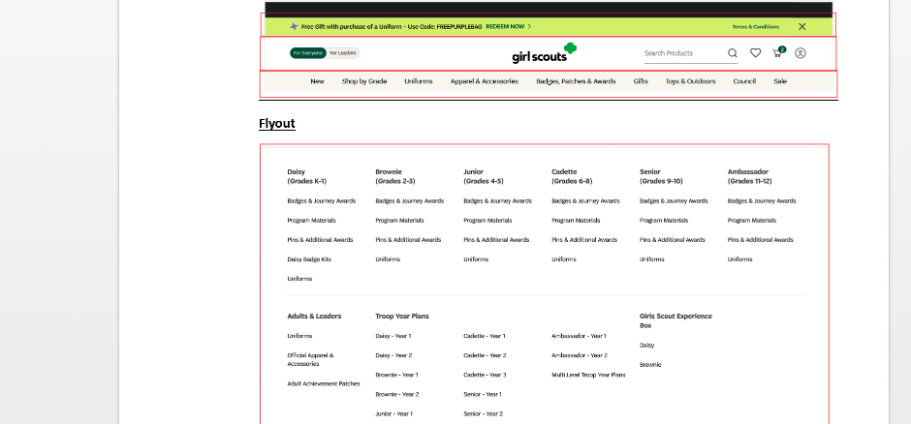
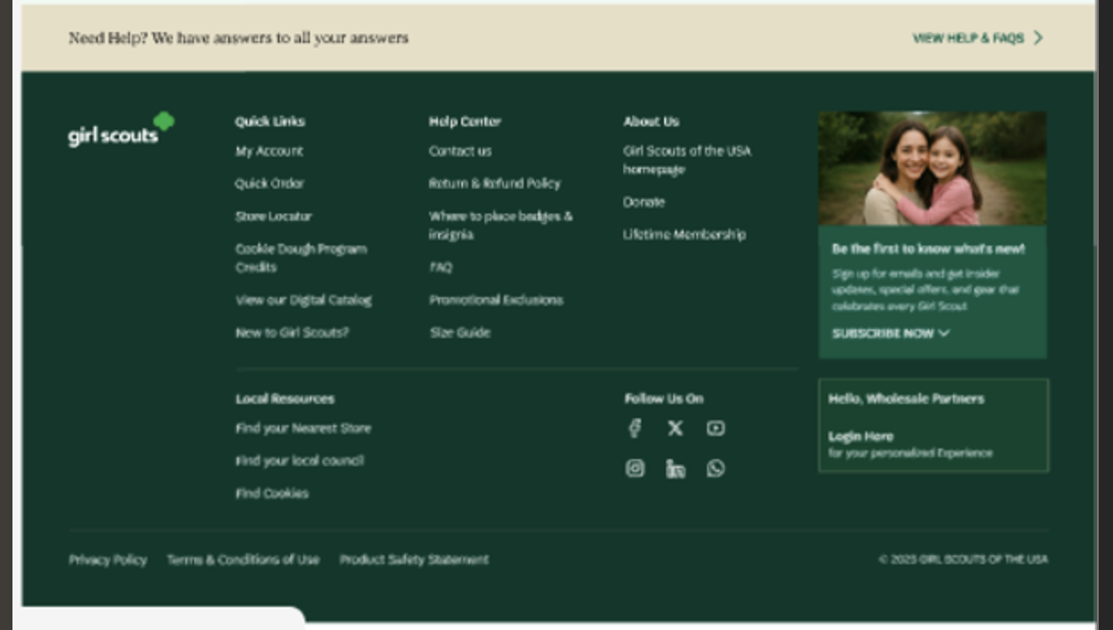

Business Questions
The tagging here will answer these questions.

- How are users navigating the site?
- Which primary nav items are most clicked?
- What percentage of users use navigation vs search?
- Are users finding what they need through navigation?
- Do nav clicks lead to deeper engagement?
- Do users bounce after certain nav paths?
- Is navigation aligned with user intent?
- Are high-demand sections buried?
- Are low-value links consuming prime space?
- Where do users drop off after navigating?
- Are some nav links leading to dead ends?
- Are category pages weak?
- Are users clicking the same nav item repeatedly?
- Indicates confusion or page not updating properly.
- Are mobile users navigating differently than desktop users?

Implementation Details

Add data-attributes* to clickable elements

Attribute | Data Type | Requirement / Rule | Examples
data-analytics-type | string | Required. Defines the UI component style. Must use a fixed, controlled vocabulary to avoid fragmentation. | nav, footer
data-analytics-location | string | Required. Defines the visual zone where the element appears. Use predefined zones only. For menus, always specify context (e.g., header vs flyout). | header, flyout
data-analytics-item | string | Required. Canonical identifier for the link. Use lowercase, kebab-case slugs. Must remain stable even if UI text changes. | uniforms, account-settings, store-locator
data-analytics-destination | string | Required. Target URL or action. Use relative paths for internal links. Use short action names for non-navigation actions. | /shop/new, /login

Example Code:
<a
href="/shop/new_uniforms"
data-analytics-type="nav"
data-analytics-location="header"
data-analytics-item="new_uniforms"
data-analytics-destination="/shop/new_uniforms"
>
New Uniforms
</a>

Errors

Business Questions
The tagging here will answer these questions.

- What % of homepage loads have errors?
- Which module fails most frequently?
- Are API failures hurting engagement?
- Is error rate higher in specific environments?
- Does error rate correlate with revenue drop?

Implementation Details
- Fire only when the error is visible or user-impacting
- Do not include stack traces
- Do not include request payloads
- Keep error codes stable and reusable
- One event per failure instance

Object Path | Key | Example | Notes
root | event | "error_event" | Standard event name
page | page_type | "homepage" | Must match controlled taxonomy
error | error_type | "api" | Controlled values
error | error_code | "HP_MODULE_TIMEOUT" | Stable internal code
error | severity | "warning" | blocking | warning
context | module | "hero_board" | Affected module
context | action | "initial_load" | Triggering action

window.dataLayer.push({
event: "error_event",

error: {
error_type: "api",
error_code: "HP_MODULE_TIMEOUT",
error_message: "Hero module failed to load",
error_field: "",
severity: "warning"
},

context: {
page_type: "homepage",
module: "hero_board",
action: "initial_load"
}
});

Search
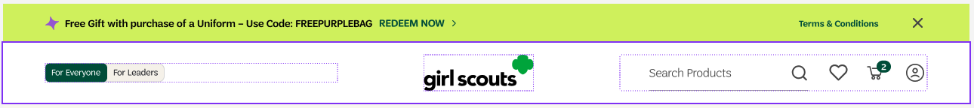

Business Questions
The tagging here will answer these questions.

- Are users struggling to find content through navigation?
- How many searches return zero results?
- Are users repeatedly searching for the same term?
- Do users abandon after searching?
- What are users actively looking for?
- Is search behavior aligned with business priorities?

Guided Navigation Selector / Search

On Click

Object | Parameter Name | Data Type | Example Value | Description
root | event | string | "search" | Event name pushed to dataLayer
search | search.term | string | "uniforms" | Search keyword entered or selected
search | search.method | string | "selector" | How the search was initiated (manual input, selector, autocomplete, guided nav)
search | search.location | string | "header" | Page location where search was initiated
search | search.module | string | "guided_navigation" | Module or UI component responsible for the search interaction
page | page.pagePath | string | / | Current page path
page | page.pageType | string | "homepage" | Logical page classification

Search Results:

Object | Parameter Name | Data Type | Example | Description
root | event | string | "search" | Name of the dataLayer event
search | search.term | string | "uniforms" | Search keyword entered or selected
search | search.method | string | "manual" | How search was initiated (manual, autocomplete, selector, guided_navigation)
search | search.location | string | "header" | UI location where search was triggered
search | search.module | string | "nav_search" | Specific component responsible for interaction
search | search.element | string | "search_input" | Specific UI element interacted with (input field, icon, button)
search | search.results_count | integer | 42 | Number of results returned for the query

Example Code:
window.dataLayer.push({
event: "search",
search: {
term: "uniforms",
method: "manual",
location: "header",
module: "nav_search",
},
page: {
pagePath: window.location.pathname,
pageType: "homepage"
}
});

On results:
window.dataLayer.push({
event: "search_results",
search: {
term: "uniforms",
method: "manual",
location: "header",
module: "nav_search",
element: "search_input",
results_count: 42
}
});

Business Questions
The tagging here will answer these questions.

- Are users struggling to find content through navigation?
- How many searches return zero results?
- Are users repeatedly searching for the same term?
- Do users abandon after searching?
- What are users actively looking for?
- Is search behavior aligned with business priorities?

Implementation Details
dataLayer Push Fire when:
- User clicks GO OR presses Enter to trigger the search request

On Click

Object | Parameter Name | Data Type | Example Value | Description
root | event | string | "search" | Event name pushed to dataLayer
search | search.term | string | "uniforms" | Search keyword entered or selected
search | search.method | string | "selector" | How the search was initiated (manual input, selector, autocomplete, guided nav)
search | search.location | string | "header" | Page location where search was initiated
search | search.module | string | "guided_navigation" | Module or UI component responsible for the search interaction
page | page.pagePath | string | / | Current page path
page | page.pageType | string | "homepage" | Logical page classification

Search Results:

Object | Parameter Name | Data Type | Example | Description
root | event | string | "search" | Name of the dataLayer event
search | search.term | string | "uniforms" | Search keyword entered or selected
search | search.method | string | "selector" | How search was initiated (manual, autocomplete, selector, guided_navigation)
search | search.location | string | "header" | UI location where search was triggered
search | search.module | string | "guided_navigation" | Specific component responsible for interaction
search | search.element | string | "search_input" | Specific UI element interacted with (input field, icon, button)
search | search.results_count | integer | 42 | Number of results returned for the query

Example Code:
window.dataLayer.push({
event: "search",
search: {
term: "uniforms",
method: "selector",
location: "header",
module: "guided_navigation",
},
page: {
pagePath: window.location.pathname,
pageType: "homepage"
}
});

On results:
window.dataLayer.push({
event: "search_results",
search: {
term: "uniforms",
method: "selector",
location: "header",
module: "guided_navigation",
element: "search_input",
results_count: 42
}
});

